Functionality
The administrative data for the costing run (name, description, selection and structure explosion) is deleted. The material cost estimates themselves are not deleted. You have to delete them in a second step (delete test data).

Scenario
You have created costing run that you no longer wanted in the system. For example costing run with wrong dates or costing variant. When you create a new costing variant, you want to delete the first one with error.

Requirements
Costing run has been created.

Menu Path | Accounting → Controlling → Product Cost Controlling → Product Cost Planning → Environment → Costing Run → CK44 - Delete Costing Run
Transaction Code | CK44

1. Double click on CK44 - Delete Costing Run.

Delete Costing Run

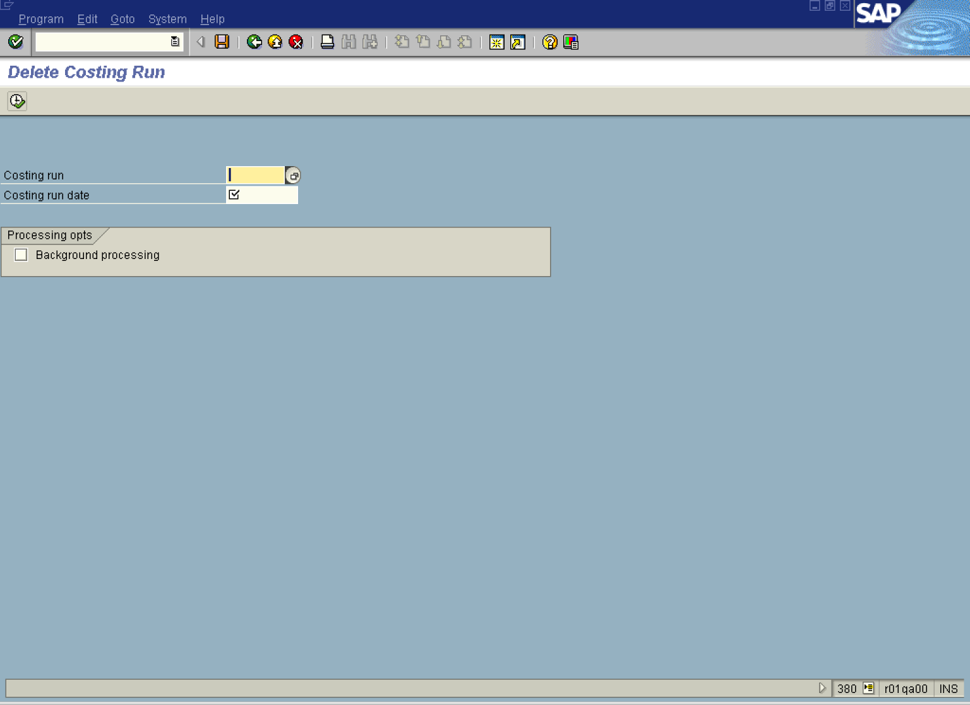

2. Press [F4] or click the Search button in the Costing run field.
Restrict value range (1)

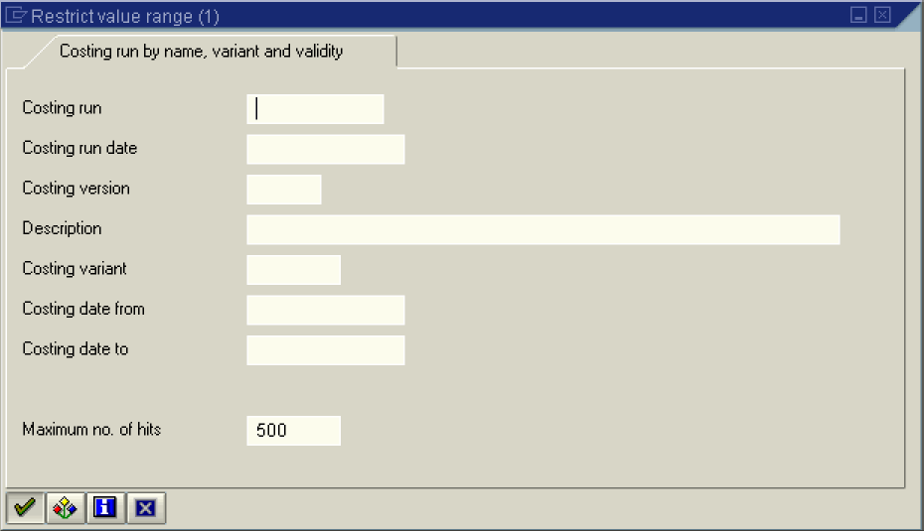

3. Click the Continue button.

Restrict value range (1) 9 Entries found

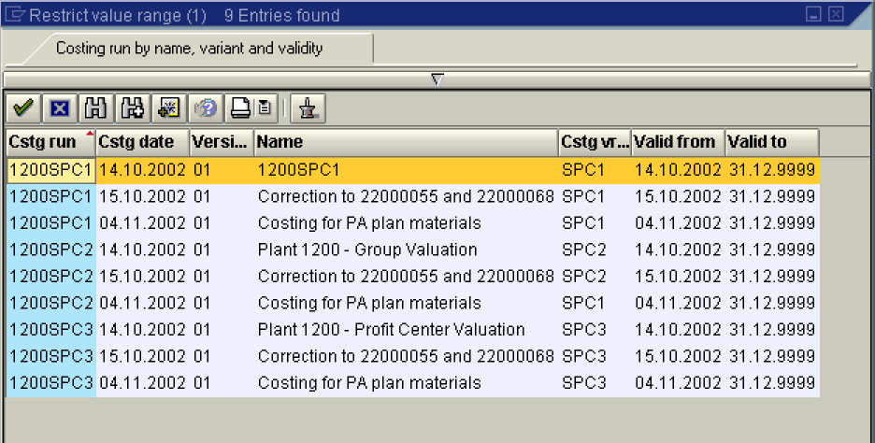

4. Double click on the 1200SPC1 - 14.10.2002 - 01 - 1200SPC1 - SPC1 - 14.10.2002 - 31.12.9999 entry in list box.

Delete Costing Run

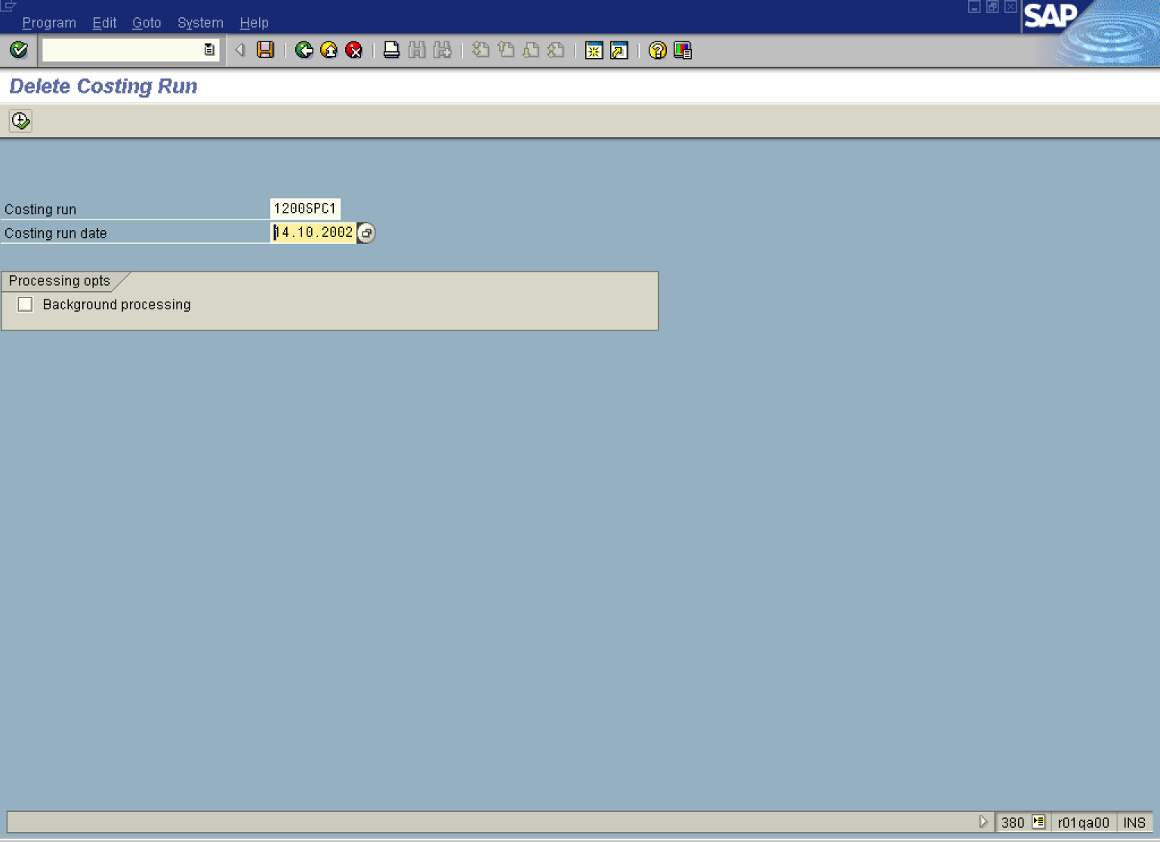

5. Update the following fields:

Field Name | Field Description | Values
Costing run date | The date of the costing run. | Example: 14.10.2002

6. Click the Execute

Delete Costing Run

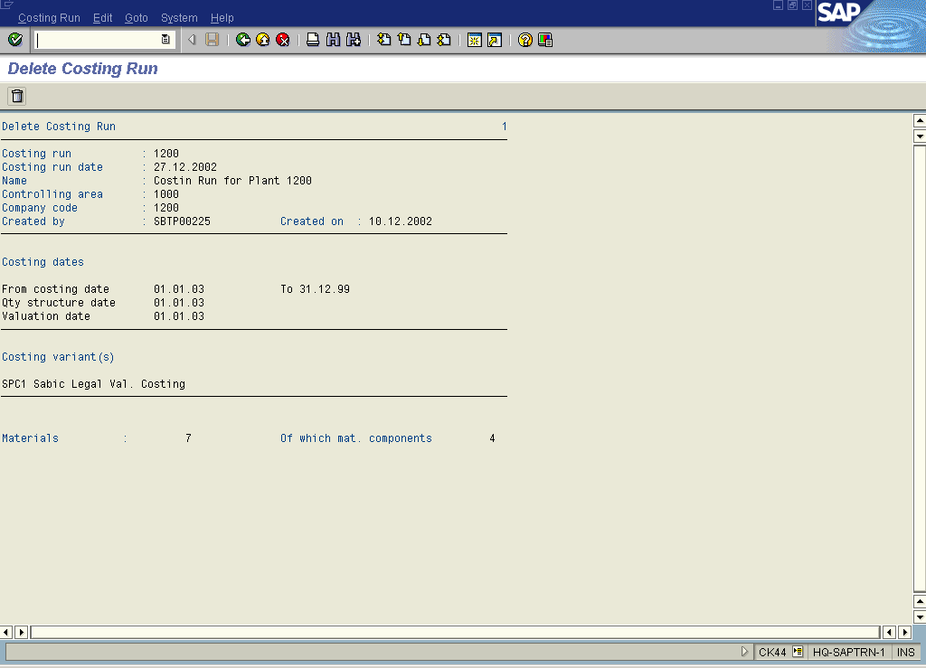

7. Click the Delete button.

Delete Costing Run

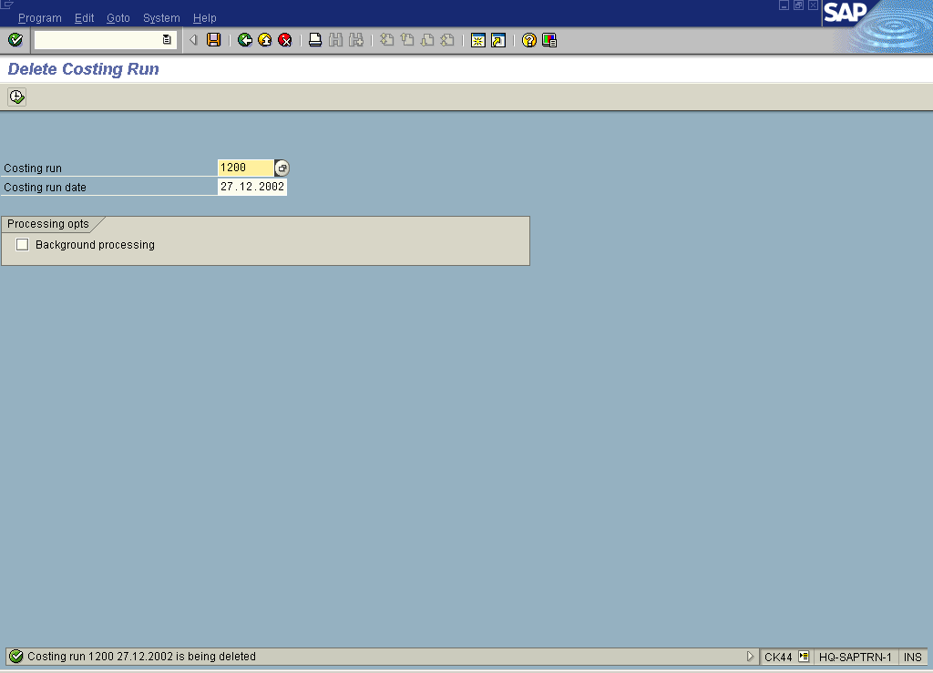

8. The message bar displays “Costing run is being deleted”

